**UX/UI Home work**

**Contenido**

**User Story 2**

**Happy Path 3**

User Story  
  
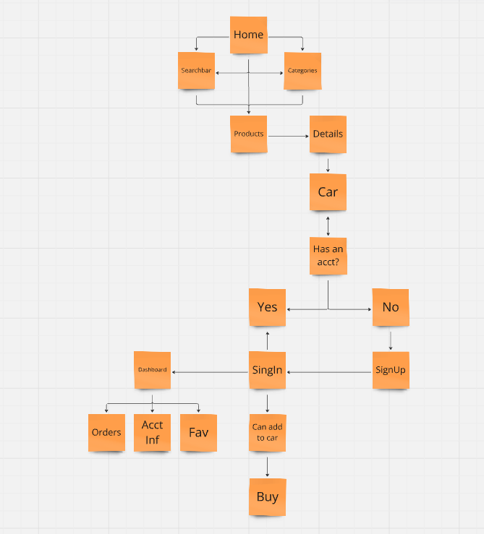

# Happy Path

